
March 18th, 2020
UTRGV Classic
(JV and Varsity)
Meet Information
Meet Director: Darren Flowers
darren.flowers@utrgv.edu

Location:
University of Texas Rio Grande Valley Soccer and Track & Field Stadium on the east side of Jackson in Edinburg, TX.
Entry Procedure:
Entries will be made on-line through Direct Athletics www.directathletics.com . Entries will close Monday Mar 16th at 7:00pm. No additions can be made after this date, only scratches. Entry fee for the UTRGV Classic is $200 per varsity team, $100 per junior varsity team. Checks should be made out to UTRGV Track and Field.
Running Events:
All running events will be timed finals. (FAT) Fully Automatic Timing.
Check In:
Heat sheets and packet pick-up will be available at the gate starting at 8:30AM on Wednesday Mar. 18th.

Directions to UTRGV Track & Field Complex
UTRGV Track & Field Complex
W University Dr.
Edinburg, TX 78539
FROM THE NORTH:

From north Expressway 281, take the Schunior Street Exit to the west (right). Head west, passing Business 281 (Closner Boulevard). Turn left on Jackson Street. Stadium will be located behind Region One near the corner of N. Jackson Road and Peridot Street.

FROM THE EAST:
From east Expressway 83 Drive west until you intersect with Expressway 281, Head North on Expressway 281 until you reach the Schunior Street Exit to the west (left). Head west, passing Business 281 (Closner Boulevard). Turn left on Jackson Street. Stadium will be located behind Region One near the corner of N. Jackson Road and Peridot Street.

FROM THE WEST:
From west Expressway 83 Drive East until you intersect with Expressway 281, Head north on Expressway 281 until you reach the Schunior Street Exit to the West (left). Head west, passing Business 281 (Closner Boulevard). Turn left on Jackson Street. Stadium will be located behind Region One near the corner of N. Jackson Road and Peridot Street.

FROM THE SOUTH:
From South Expressway 281, take the Schunior Street Exit to the west (left). Head west, passing Business 281
(Closner Boulevard). Turn left on Jackson Street. Stadium will be located behind Region One near the corner of N. Jackson Road and Peridot Street.

Team Bus Parking
Bus pick up/drop off will be located just to the north of the facility on the service road that can be accessed from Jackson Street. Bus parking will be located at the Region One facility north of the track. Additional parking for smaller vehicles will be located to the west of the complex in the parking lot near the main facility entrance.

Clerking and Check-In
Track Events Athletes will check-in at the Clerk’s Table located on the northwest end of the facility near scoreboard. Only athletes who have checked in will be allowed to use the “active warm-up area.” Competitors in all track events will be issued two hip numbers each, to be worn on the left hip and left chest. Distance runners will be issued hip numbers on both hips and the left chest.

Field Events
Athletes should check in with the head official at the event site one hour before the event begins (vaulters 1.5 hours prior).

Inclement Weather
In the event of inclement weather or a disaster of any kind, as it is determined by the Championship Officials, Host Meet Management Officials and/or University Police Department personnel, the following plan has been established should it be necessary to evacuate the competition venue.

All student-athletes/coaches/trainers from the competing institutions will be evacuated to their team buses/vans or into the UTRGV Wellness and Recreation Center. All meet and championship officials will be directed to Officials Locker Rooms northwest of the track. All fans/patrons will be directed to the UTRGV Wellness and Recreation Center. Following NCAA protocol, an online lightning detection and weather monitoring system will be used. The complete UTRGV Track Lightning Safety Policy is available in Appendix 5.

Medical Procedures
A certified athletic trainer will be on site for all sessions of competition provided by UTRGV. In addition to certified athletic trainers, there will be student athletic trainers stationed throughout the facility.

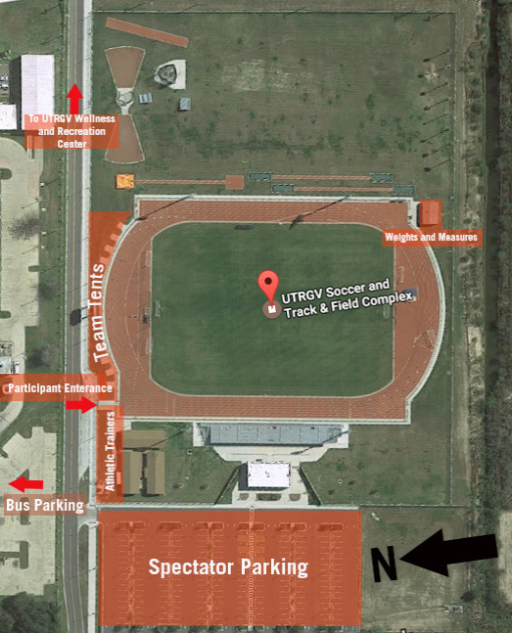

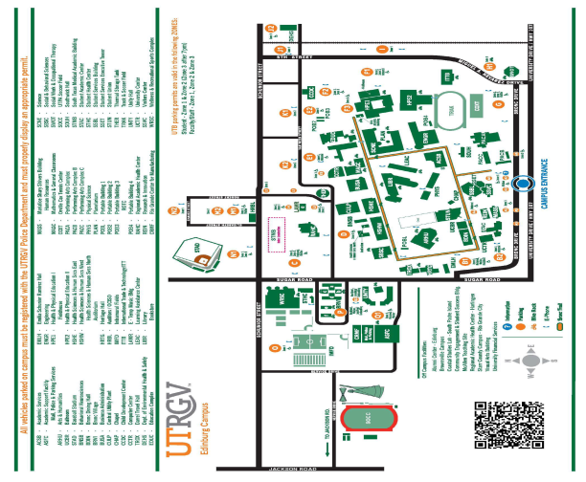

Track Lightning Safety Policy Revised 6/8/15 Track Lightning Safety Policy In an effort to protect the student-athletes, coaching staff, support staff, fans and officials from the possibility of a lightning strike, this guide has been designed for the safety of all those involved with intercollegiate athletics at UTRGV. DESIGNATED CHAIN OF COMMAND It will be the responsibility of the staff Athletic Trainer, working closely in conjunction with the Head Coach or lead official, to decide if the event needs to be delayed or cancelled due to the possibility of a lightning strike occurring. If the event has already started, either the staff Athletic Trainer or lead event official will communicate with the coaching staff to determine if the event should be postponed or cancelled. However, the staff Athletic Trainer, as a representative of the University, will have the final say regarding curtailment or postponement of an event. If the staff Athletic Trainer is not immediately available, the head coach or their designated assistant coach in charge will be responsible for removing a team or individuals from the athletic site. METHODS FOR MONITORING WEATHER Coaches, athletic trainers and sports information/press box staff should check the weather daily prior to an event or practice. One of the best methods is on the internet at (www.weather.com or www.noaa.com, etc.) These websites can give you a weather report as well as an up to date view of radar in the surrounding area. METHODS FOR DETECTING LIGHTNING 1) SKY SCAN – Our Athletic Department uses this device to detect lightning in the area. However, this device only gives an approximate distance of lightning. It cannot predict the next lightning strike. If the Sky Scan detects lightning within an 10 mile area, the Sports Medicine Staff will instruct the coaching staff and event officials to suspend play and to seek shelter indoors. 2) WEATHERBUG SPARK APP - In addition, each member of the Sports Medicine Staff has access to the SPARK App on their cell phone, which assists in identifying the proximity of lightning strikes in the area. If SPARK detects lightning within an 10 mile area, the Sports Medicine Staff will instruct the coaching staff and event officials to suspend play and to seek shelter indoors. RESUMPTION OF ACTIVITIES It is considered safe to return to play 30 minutes after the last flash of lightning has passed the 10 mile radius. Officials will be given a “green light” to resume activities 30 minutes after the last registered warning on the Sky Scan or SPARK. If another warning occurs on the Sky Scan or SPARK within the 30 minute delay period, the clock will start for an additional 30 minute delay. FACTS REGARDING LIGHTNING SAFETY ♣ Blue sky and no rain are not protection from lightning. Lightning can strike as far as 10 miles away from rain. It does not have to be raining for a lightning strike. ♣ Avoid using a land line telephone except in emergency situations. A cellular phone or a portable remote phone is a safe alternative as long as the person and antenna are located within a safe structure. ♣ Minimize your body’s surface area and minimize contact with the ground. DO NOT LAY FLAT! Lightning current often enters through the ground rather than by a direct overhead strike. ♣ If unable to reach safe shelter stay away from tall trees or objects (light poles, flag poles, etc.), metal objects, individual trees, standing pools of water, and open fields. Do not be the tallest object in a field. Do not take shelter under a single tall object. ♣ If a person feels his or her hair stand on end, or skin tingle, they should immediately get into a crouched position.

Track Lightning Safety Policy Revised 6/8/15 SAFE SHELTER It is important to be familiar with the nearest safe shelter; a safe shelter is considered a building normally occupied or regularly used by people. Example: a building with plumbing and or electrical wiring that acts to electrically ground the structure. An awning or covered area is not considered a safe shelter. If safe shelter is not available, a vehicle can be used (not a convertible or a cart). Make sure the windows are rolled up. A vehicle is better than remaining outdoors. The rubber tires do not make the vehicle safer but rather the metal roof, which helps dissipate the lightning strike around the vehicle. DO NOT TOUCH THE SIDES OF THE VEHICLE! In the absence of a safe shelter or vehicle any open shelter can be used. While this is not a preferred method, this shelter can be used. If there is not a safe structure within a reasonable distance, find a thick grove of small trees surrounded by taller trees or a dry ditch. Assume a crouched position on the ground with only the balls of the feet touching the ground. Wrap your arms around your knees and lower your head. Minimize contact with the ground. GENERAL ANNOUNCEMENT If monitoring an approaching storm, the Sports Medicine Staff will notify the event announcer to make an initial public address announcement so the spectators are aware that there may be a need to seek shelter. If the area is to be evacuated due to lightning, a second public address announcement should be made advising the spectators to seek safe shelter immediately. EVACUATION In the event that an evacuation is necessary the following venues will use the following designated safe buildings: Safe shelters for the UTRGV Track/Soccer facility are inside the Track storage building (stay away from metal walls of building); he Training Room (portable building) or the Men’s and Women’s Track locker rooms (portable buildings) at the Track Stadium. The restrooms may also be used as safe shelter. Visiting teams and spectators may also choose to seek shelter in their team or individual vehicles.

